Balanced search trees — AVL, red-black, and splay trees
Sun, 10 May 26
Balanced Search Trees Overview
- Binary search trees support O(log n) operations in average case
- Worst case performance degrades to O(h) where h = height
- Right-skewed trees create h proportional to n, resulting in O(n) complexity
- Fundamental goal: reduce height after insertion/deletion operations
Height Reduction Techniques
- Reshaping through rotations/restructuring operations
- Maintains binary search tree properties during modifications
- Parent-child relationships modified in unit time O(1)
- Operations preserve search tree conditions while improving balance
Types of Balanced Search Trees
- AVL trees
- Red-black trees
- Splay trees
- All maintain binary search tree properties
- Classified as balanced binary search trees or balanced search trees
Key Performance Benefits
- Better worst-case time complexity through height management
- Consistent O(log n) performance across operations
- Automatic rebalancing after structural changes
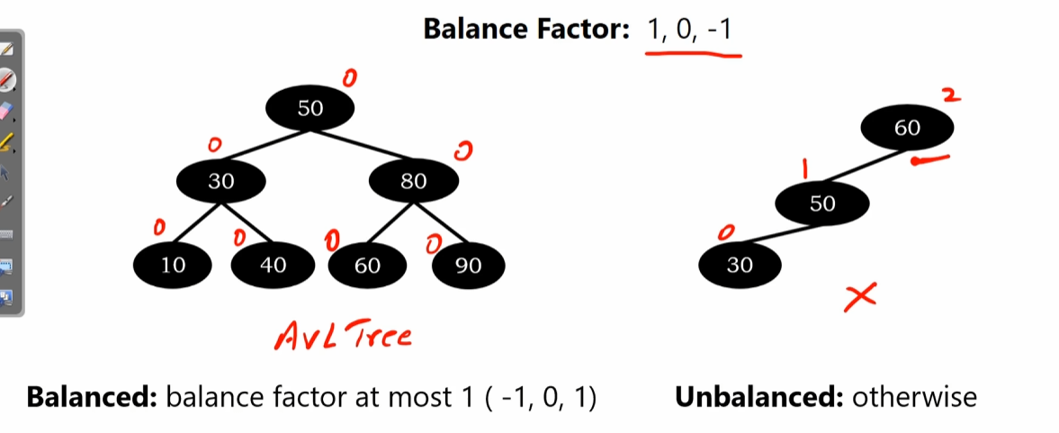
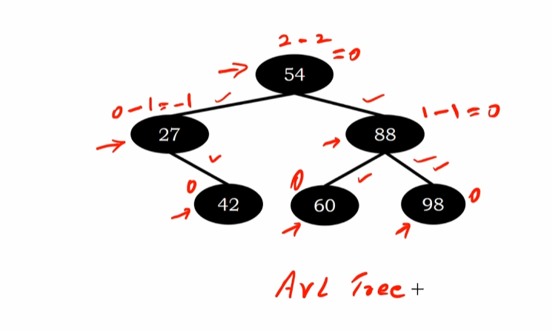
AVL tree rotations — LL, RR, LR, and RL
Sun, 10 May 26
AVL Tree Rotation Fundamentals
- Four rotation types for rebalancing after node insertion
  - LL rotation (left-left case)
  - RR rotation (right-right case)
  - LR rotation (left-right case)
  - RL rotation (right-left case)
- Rotations always involve exactly 3 nodes regardless of tree size
  - Tree rebalanced after every insertion
  - Only affected subtree needs rotation
LL Rotation (Left-Left Case)
- Triggered when insertion causes left-heavy imbalance
- Example sequence: Insert 60 → 50 → 30
  - Node 60 balance factor becomes +2 (unbalanced)
  - Perform clockwise rotation at unbalanced node (60)
- Result: Node 50 becomes new root
  - 30 remains left child of 50
  - 60 becomes right child of 50
  - All balance factors return to 0
RR Rotation (Right-Right Case)
- Triggered when insertion causes right-heavy imbalance
- Example sequence: Insert 30 → 50 → 60
  - Node 30 balance factor becomes -2 (unbalanced)
  - Perform anti-clockwise rotation at unbalanced node (30)
- Result: Node 50 becomes new root
  - 30 becomes left child of 50
  - 60 remains right child of 50
  - All balance factors return to 0
LR Rotation (Left-Right Case)
- Triggered when insertion creates left-right imbalance pattern
- Example sequence: Insert 60 → 30 → 50
  - Node 60 balance factor becomes +2 (unbalanced)
  - Two-step rotation required (more complex than LL/RR)
- Result: Node 50 becomes new root
  - 30 becomes left child of 50
  - 60 becomes right child of 50
  - All balance factors return to 0
RL Rotation (Right-Left Case)
- Triggered when insertion creates right-left imbalance pattern
- Example sequence: Insert 30 → 60 → 50
  - Node 30 balance factor becomes -2 (unbalanced)
  - Two-step rotation: make 50 root, then anti-clockwise
- Result: Node 50 becomes new root
  - 30 becomes left child of 50
  - 60 becomes right child of 50
  - All balance factors return to 0
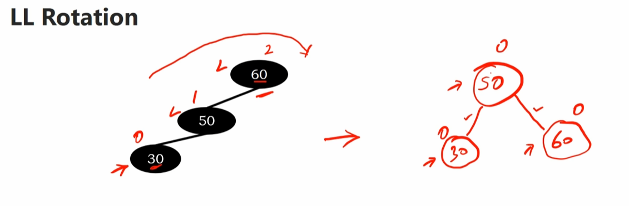
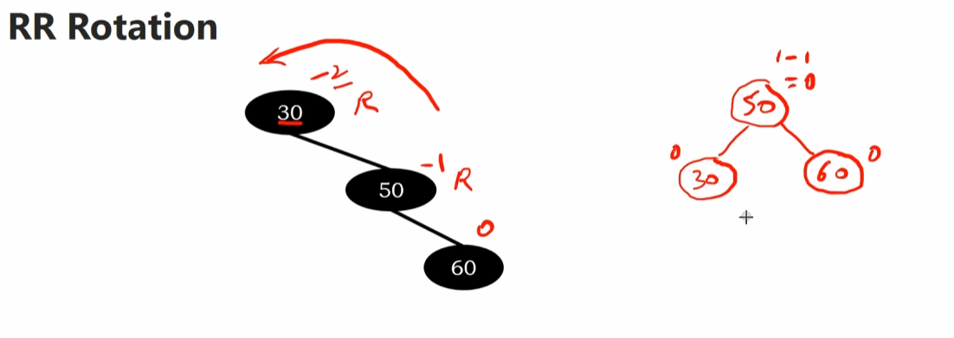
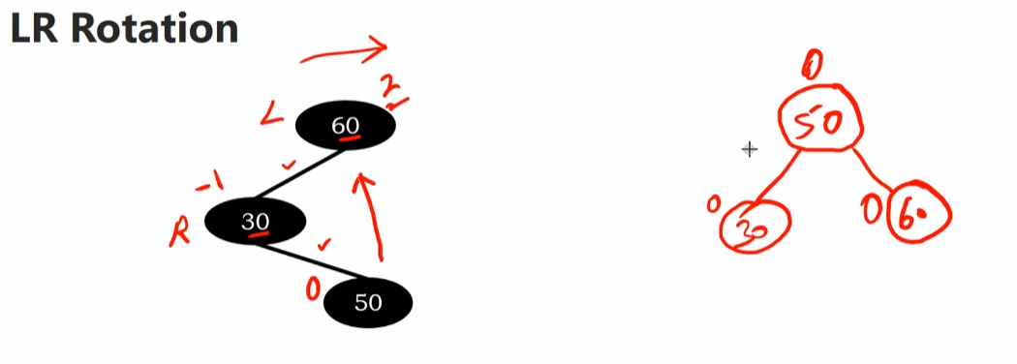

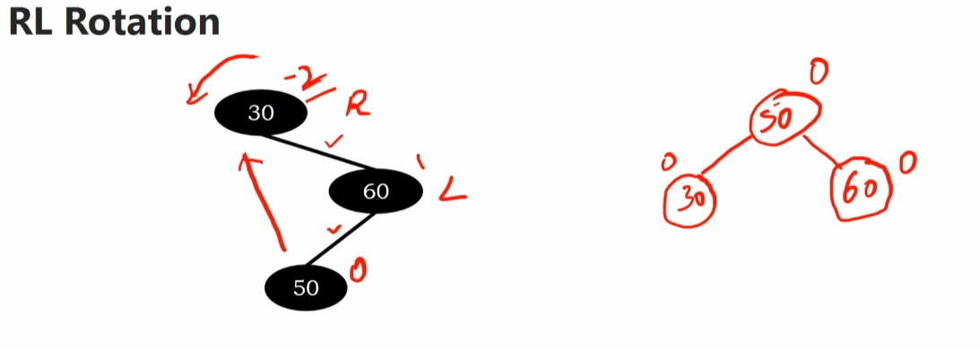

LL rotation in binary search trees — balance factor examples
Sun, 10 May 26
LL Rotation Concept
- Rotation technique for rebalancing binary search trees when left-left imbalance occurs
- Applied when node becomes unbalanced due to insertion in left subtree of left child
- Three-node restructuring process:
  - Node B becomes new root
  - Node A becomes right child of B
  - Node C becomes left child of B
Subtree Redistribution Rules
- Original right subtree of A remains as right subtree of A
- Left and right subtrees of C remain unchanged
- Right subtree of B becomes left subtree of A after rotation
- Maintains binary search tree property throughout transformation
Practical Example Walkthrough
- Initial BST with nodes 15, 20, 30, 35, 40, 50, 55, 60, 65, 90
- Balance factors calculated for each node (range -1 to +1 = balanced)
- Insertion of node 15 causes imbalance:
  - Node 60 balance factor becomes +2 (unbalanced)
  - Triggers LL rotation requirement
- Three-node rotation performed on nodes 60, 40, 30:
  - Node 40 becomes new root
  - Node 60 becomes right child
  - Subtrees 50, 55 move to become left subtree of node 60
Post-Rotation Results
- All balance factors return to acceptable range (-1 to +1)
- Tree maintains AVL property with improved balance
- Demonstrates successful rebalancing of larger binary search tree structure
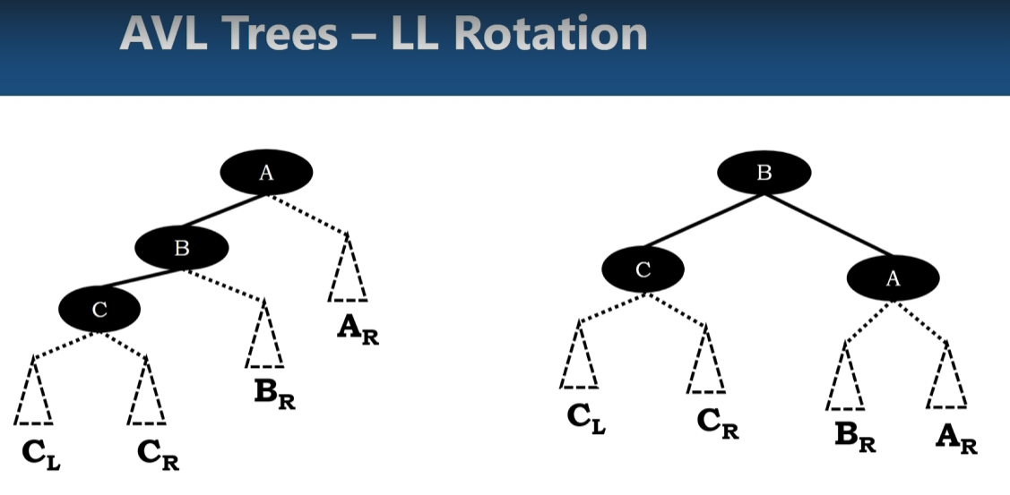
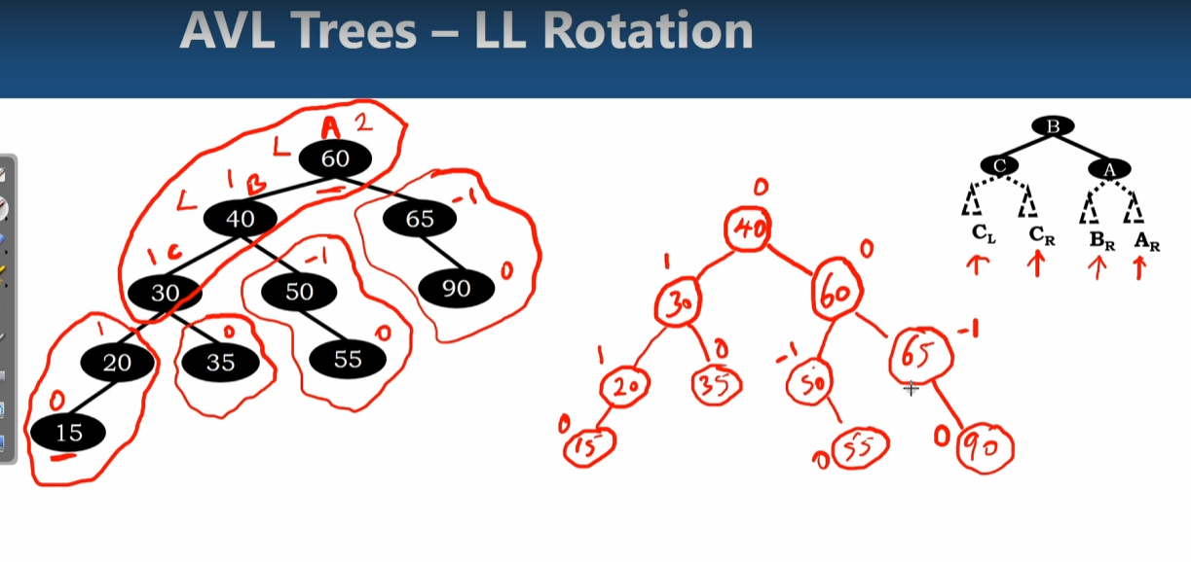
AVL tree rotations — RR rotation example and rebalancing
Sun, 10 May 26
RR Rotation Concept Overview
- Extension of basic rotation logic to larger binary search trees
- Maintains BST properties while rebalancing unbalanced nodes
- Focuses on three-node rotation pattern regardless of tree size
RR Rotation Mechanics
- Node structure transformation:
  - Original unbalanced node (A) becomes left child
  - Middle node (B) becomes new root
  - Right node © becomes right child of new root
- Subtree preservation rules:
  - Left subtree of A remains unchanged
  - Left subtree of B becomes right subtree of A
  - Left and right subtrees of C remain unchanged
Practical Example Walkthrough
- Initial tree state:
  - All nodes balanced (balance factors ≤ 1)
  - Node 60 has balance factor -1
- After inserting node 95:
  - Node 95 inserted as right child of node 90
  - Node 60 balance factor becomes -2 (unbalanced)
  - Triggers RR rotation requirement
- Rotation execution:
  - Node 70 becomes new root
  - Node 60 becomes left child of 70
  - Node 80 becomes right child of 70
  - Subtree 65-62 moves to right of node 60
Post-Rotation Results
- All balance factors return to acceptable range (≤ 1)
- Tree maintains AVL property
- Final balance factors:
  - Node 70: 0 (height 3 both sides)
  - Node 60: 0 (height 2 both sides)
  - Node 80: -1, Node 90: -1
- Demonstrates successful rebalancing of larger BST using three-node rotation focus
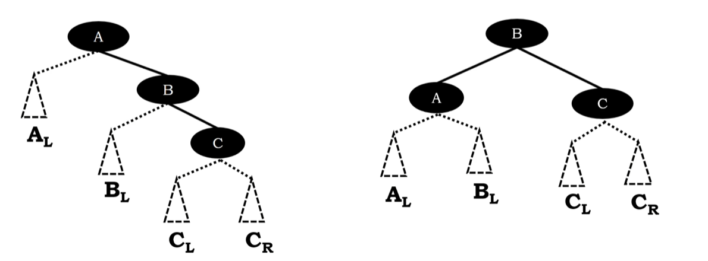
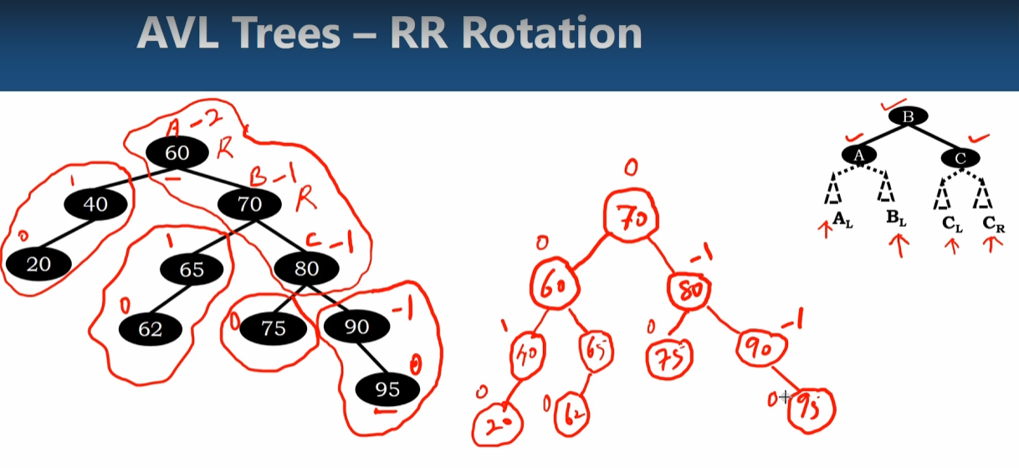
LR rotation in AVL trees — theory and practical example
Sun, 10 May 26
LR Rotation Theory
- Rotation performed on unbalanced node (node A)
- Node C becomes new root of subtree
  - Node B becomes left child of C
  - Node A becomes right child of C
- Subtree redistribution rules:
  - AR (right subtree of A) remains with A
  - BL (left subtree of B) remains with B
  - CL (left subtree of C) becomes right subtree of B
  - CR (right subtree of C) becomes left subtree of A
Practical Example Setup
- Initial BST with all balance factors ≤ 1 (valid AVL tree)
- Key nodes: 20, 30, 40, 45, 50, 55, 60, 65, 90
- Insert node 48 as right child of node 45
- Node 60 balance factor becomes 2 (left height 4, right height 2)
- Tree becomes unbalanced at node 60
LR Rotation Execution
- Target nodes for rotation:
  - Node 60 (A) - unbalanced node
  - Node 40 (B) - left child
  - Node 50 © - right child of B
- Post-rotation structure:
  - Node 50 becomes root
  - Node 40 becomes left child of 50
  - Node 60 becomes right child of 50
Final Tree Balance
- Subtree adjustments:
  - Nodes 30, 20 remain left subtree of 40
  - Nodes 65, 90 remain right subtree of 60
  - Nodes 45, 48 become right subtree of 40
  - Node 55 becomes left subtree of 60
- All balance factors now ≤ 1
- AVL tree property restored
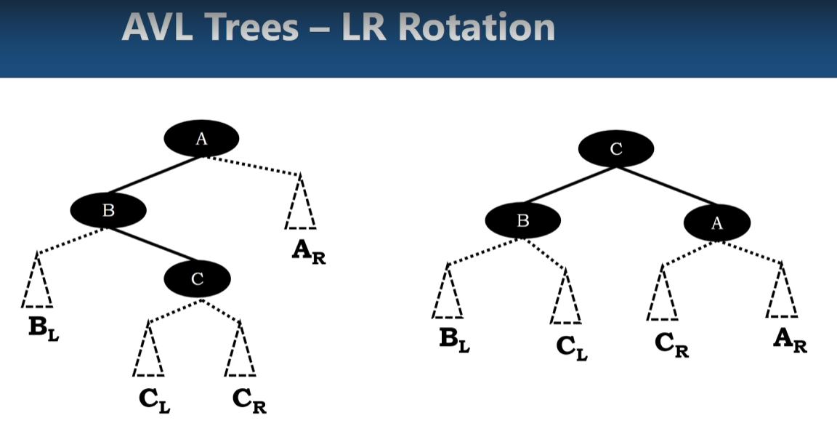
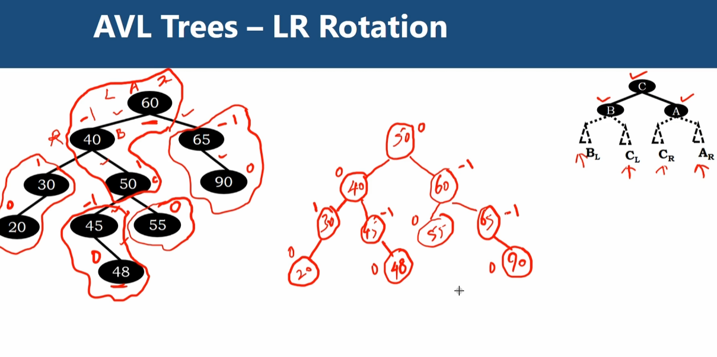

AVL tree rotations — RL rotation on larger binary search trees
Sun, 10 May 26
RL Rotation Concept Overview
- Extension of 3-node RL rotation to larger binary search trees
- Node structure for larger trees:
  - Node A (unbalanced node) with right subtree Node D
  - Node A has left subtree AL
  - Node B with left subtree Node C and right subtree BR
  - Node C has left subtree CL and right subtree CR
RL Rotation Mechanics
- Node C becomes root of subtree after rotation
- Node positioning after rotation:
  - Node A becomes left child of Node C
  - Node B becomes right child of Node C
- Subtree redistribution:
  - AL remains as Node A’s left subtree
  - BR remains as Node B’s right subtree
  - CL becomes Node A’s right subtree
  - CR becomes Node B’s left subtree
Practical Example Implementation
- Initial balanced BST with nodes 20, 40, 60, 65, 70, 75, 80, 85, 90
- All balance factors ≤ 1 (balanced AVL tree)
- Insertion of node 62:
  - Placed as left child of node 65
  - Node 60 balance factor becomes -2 (unbalanced)
  - Triggers RL rotation requirement
Rotation Execution Results
- Three-node rotation: Node 60 (A), Node 80 (B), Node 70 ©
- Post-rotation structure:
  - Node 70 becomes subtree root
  - Node 60 becomes left child, Node 80 becomes right child
  - Nodes 65, 62 become right subtree of Node 60
  - Node 75 becomes left subtree of Node 80
- Final balance factors all ≤ 1, restoring AVL tree property
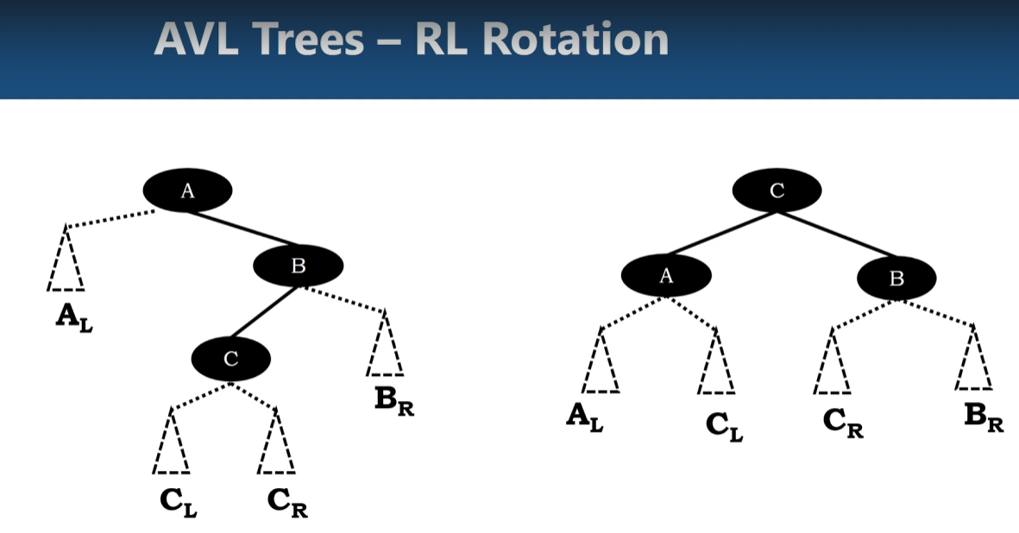
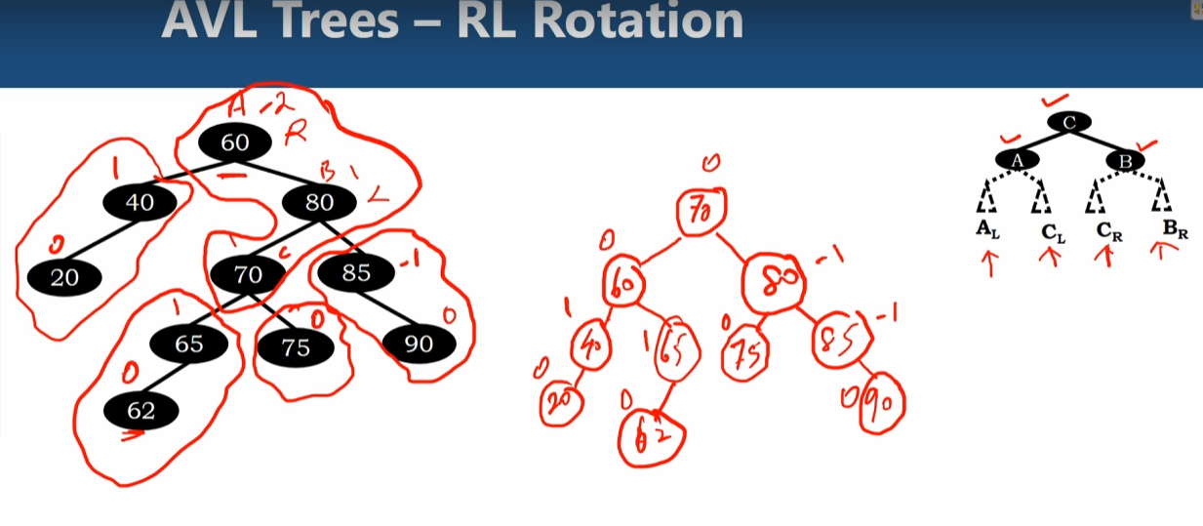

AVL tree deletion — rotations and rebalancing
Sun, 10 May 26
AVL Tree Deletion Overview
- Deletion follows binary search tree rules
- Four rotation types needed to rebalance after deletion:
  - LL rotation (clockwise)
  - RR rotation (counter-clockwise)
  - LR rotation
  - RL rotation
- Only affects 3 nodes requiring rotation to restore balance
LL Rotation Examples
- Basic LL case: Node 70 deleted from balanced tree
  - Node 60 balance factor becomes 2 (unbalanced)
  - Perform clockwise rotation at node 60
  - Node 50 becomes new root, maintains BST properties
- LL with additional left child: Node 70 deleted, node 20 present
  - Can choose LL or LR rotation
  - LL: Node 30 becomes root, maintains balance factors ≤1
  - LR: Node 50 becomes root, alternative valid solution
RR Rotation Cases
- Basic RR case: Node 20 deleted
  - Node 30 balance factor becomes -2 (unbalanced)
  - Node 50 becomes new root via counter-clockwise rotation
  - All nodes achieve balance factor 0
- RR with additional right child: Node 20 deleted, node 70 present
  - Can perform RR or RL rotation
  - RR: Node 60 becomes root
  - RL: Node 50 becomes root, both maintain balance
Key Balance Factor Rules
- Balanced tree: all nodes have balance factor -1, 0, or 1
- Unbalanced: balance factor ±2 triggers rotation requirement
- Height calculation: left subtree height - right subtree height
- Deletion affects ancestor node heights up the tree
Rotation Selection Strategy
- When both rotations possible, either maintains AVL properties
- Choice depends on desired tree structure
- All rotations preserve binary search tree ordering
- Final balance factors must be within [-1, 1] range
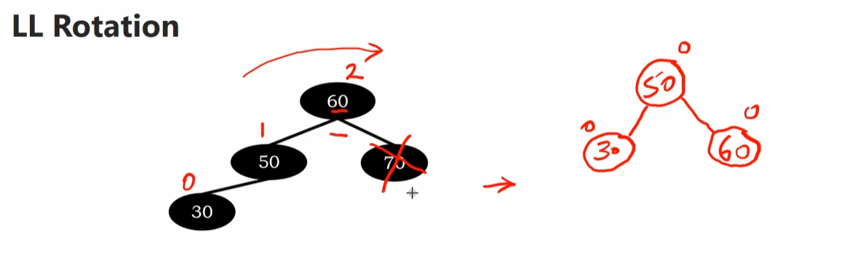
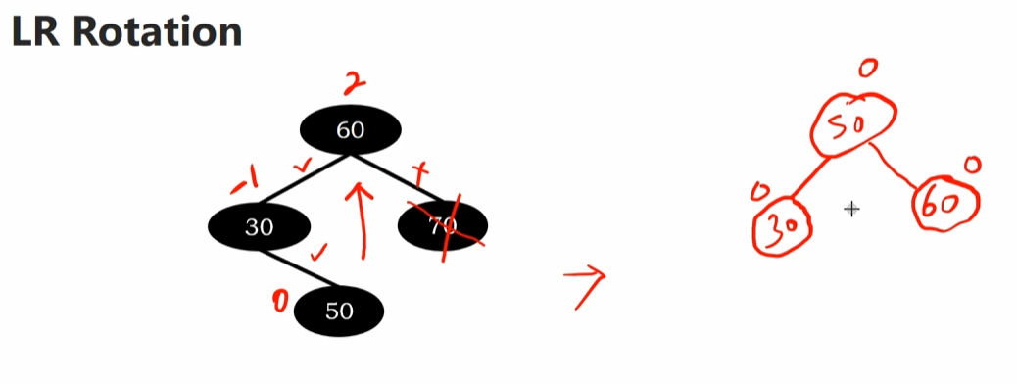
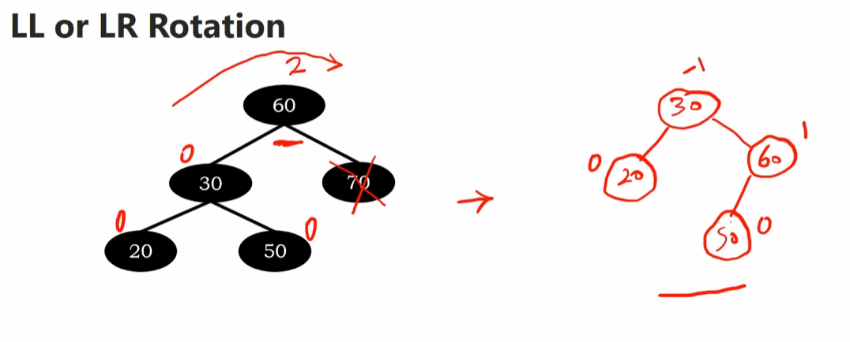
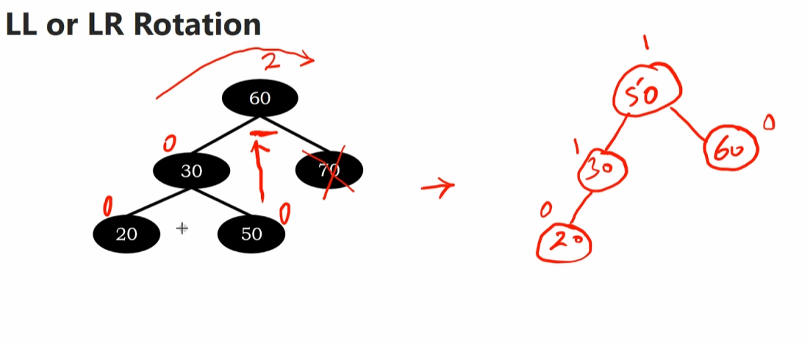
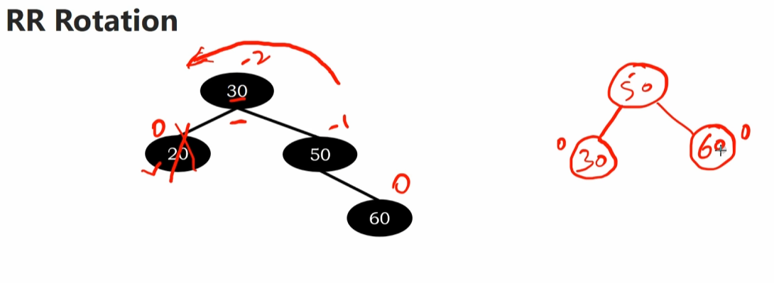
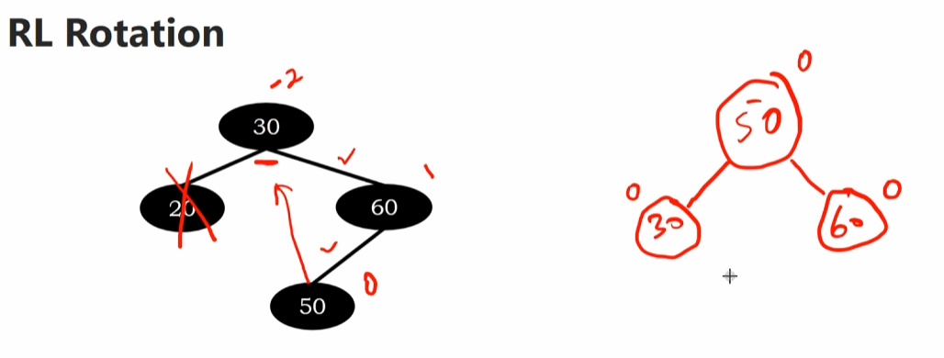
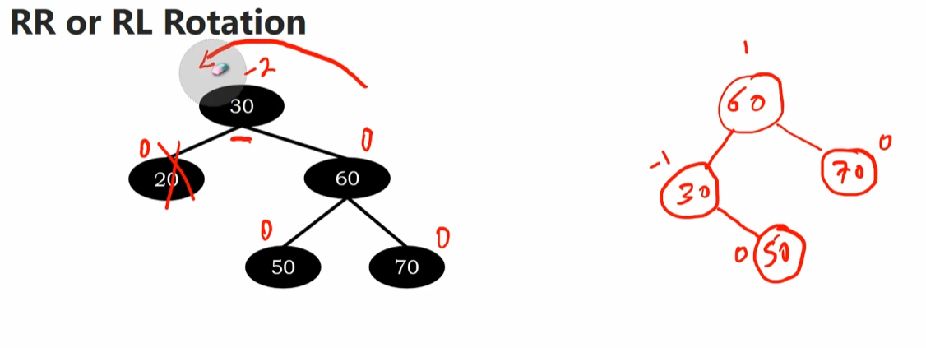

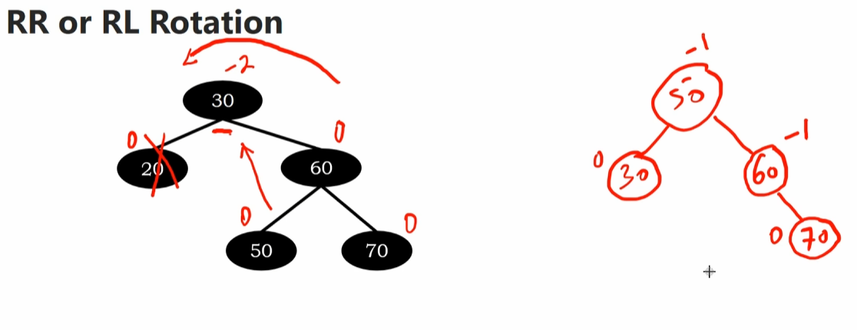
AVL tree runtime performance analysis
Sun, 10 May 26
AVL Tree Runtime Performance Overview
- Time complexity analysis for AVL tree operations
- All primary operations (search, insert, delete) achieve O(log n) performance
- Performance guaranteed through height-balanced property maintenance
Rotation Operations
- Four rotation types available for tree balancing
- Rotations modify parent-child relationships
- Operations affect constant number of nodes
- Time complexity: O(1) for all rotations
  - Unit time performance regardless of tree size
  - Critical for maintaining balance efficiency
Height Properties & Guarantees
- AVL tree height with n elements guaranteed to be O(log n)
- Height balance maintained through reshaping at each level
- Node balancing operations take unit time
- Balanced nodes at every level ensure optimal performance
Core Operation Performance
- Search operations: O(log n) worst-case time complexity
  - Guaranteed by height property maintenance
- Insert operations: O(log n) time complexity
  - Includes restructuring after insertion
- Delete operations: O(log n) time complexity
  - Automatic restructuring restores height balance
  - Height guarantee preserved after each operation
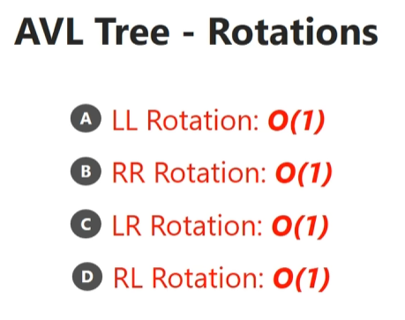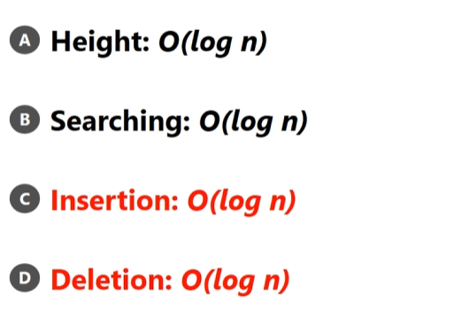

Red black trees — properties and structure
Sun, 10 May 26
Red-Black Trees Overview
- Balanced binary search tree data structure with colored nodes (red/black)
- Better performance than AVL trees for restructuring after insertions/deletions
- Fewer rotation operations required compared to AVL trees
Core Properties
- Root property: Root node always black
- Red property: Red nodes must have black children
  - No two successive red nodes allowed in any path
- Depth property: All paths from root to leaf contain equal number of black nodes
  - Ensures balanced tree structure
Example Analysis
- Sample tree with root node 60 (black)
- Red nodes: 50 and leaf nodes
  - Node 50’s children (45, 56) are black - satisfies red property
- Black depth verification across all paths:
  - Root to node 25: 3 black nodes
  - Root to node 35: 3 black nodes (60, 30, 45)
  - Root to node 48: 3 black nodes (60, 30, 45)
  - Root to node 56: 3 black nodes (60, 30, 56)
  - Root to node 65: 3 black nodes (60, 70, 62)
  - Root to node 90: 3 black nodes
- All paths maintain consistent black depth = balanced tree
Next Topics
- Upcoming videos will cover restructuring operations
- Focus on maintaining balance after tree becomes unbalanced
